Mechanisms
​All of the Operator, Task, Executive Task and 24 Hour Back Care Chairs are fitted with one of the following heavy duty, precision engineered mechanisms. Where indicated they also have a seat slider fitted as standard or available as an option.
Operator
This mechanism has lever operated back angle adjustment that can be locked in any position or left to follow the user's movements in dynamic free float mode.
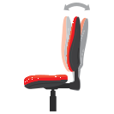
Operator Plus
Similar to the Operator mechanism but with additional, lever activated, seat tilt adjustment. Where indicated, most include tension control to adjust for different user weights.
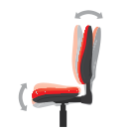
Operator Synchro
With this mechanism the back and seat recline together in a fixed 2:1 ratio. They can be locked in position or left to follow the user's movements in dynamic, free float mode. They have adjustable tension control.

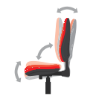
Knee Tilt
The lever operated Knee Tilt mechanism has a forward pivot point for reduced knee lift and a superior ride quality. It has a tension adjustable free float mode or it can be locked in any of 5 set positions.
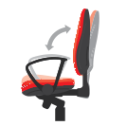
Synchro Knee Tilt
This mechanism synchronises the back and seat in a 2:1 ratio with a forward pivot point. It has a tension adjustable free float mode or it can be locked in any of 5 set positions.
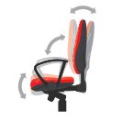
Synchro Plus
This mechanism combines the superior ride quality of a synchronised mechanism with the breadth of adjustability of an Operator Plus mechanism. The back angle can be set independently of the synchronised seat and back function.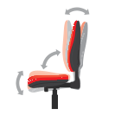

Seat Slider
Where fitted, a seat slider facilitates horizontal seat adjustment. This is ideal for extra leg support or where a chair might have multiple users with different seat depth requirements.
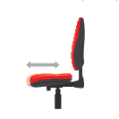
Inflatable Lumbar Supports
Chairs fitted with an integrated, inflatable lumbar support and ratchet back height adjustment allows the user to precisely locate and adjust the degree of lumbar support as required. On some chairs the inflatable lumbar is standard and available as an option on the other ranges where indicated.
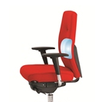
Gas Lifts
All of our swivel chairs are fitted with a gas lift for easy height adjustment. These are suitable for people up to 150kg in weight. The gas lifts fitted to the Posturemax 200 range chairs are suitable for people up to 200kgs in weight.

